Math 189: Discrete Mathematics

Proof Analysis

# Rob Peterson

Part 1: List of mathematical terms



Continued on next page …

Part 1: list of mathematical terms:



Continued on next page …

Part 1: list of mathematical terms:

Continued on next page …

Part 1: List of Mathematical Terms



Part 2: List of mathematical Symbols



Continued on next page …

Part 2: List of Mathematical Symbols:



**Part 3: Proof StoryBoard**

The following is a storyboard that illustrates the steps of the proof in Zybooks Discrete mathematics text theorem 6.8.1:

If G has a positive length cycle, then there is a path <v0,...,vk> in G where v0 = vk and k ≥ 1.

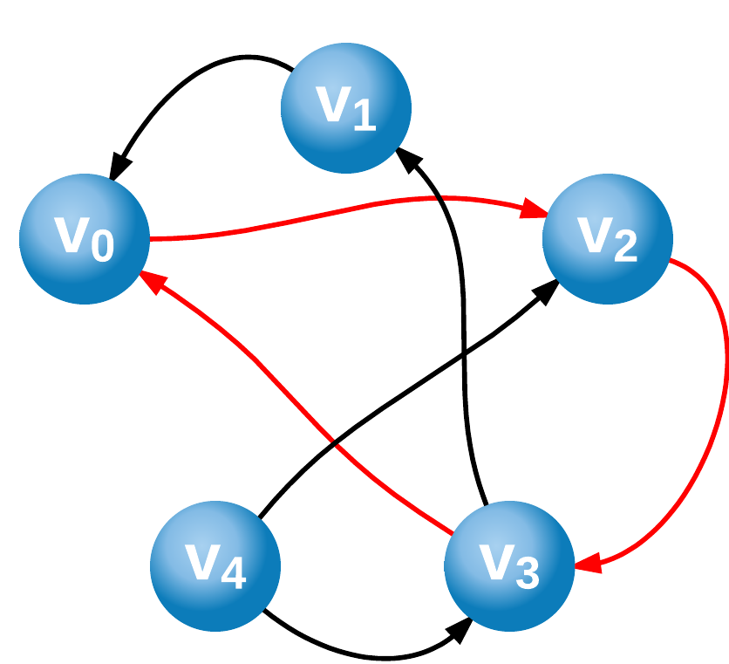

Figure : Directed Graph G having positive length cycle <v0, v2, v3, v0>

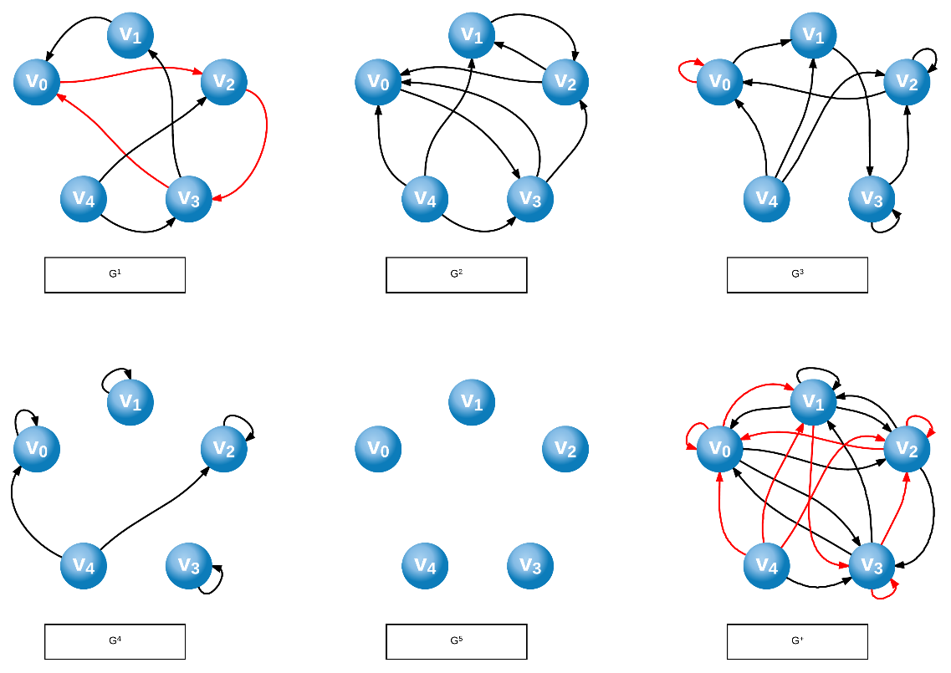

Figure : The 5 graph powers and the transitive closure are pictured for reference.

The existence of the path of length k implies that there is an edge (v0, vk) in Gk.

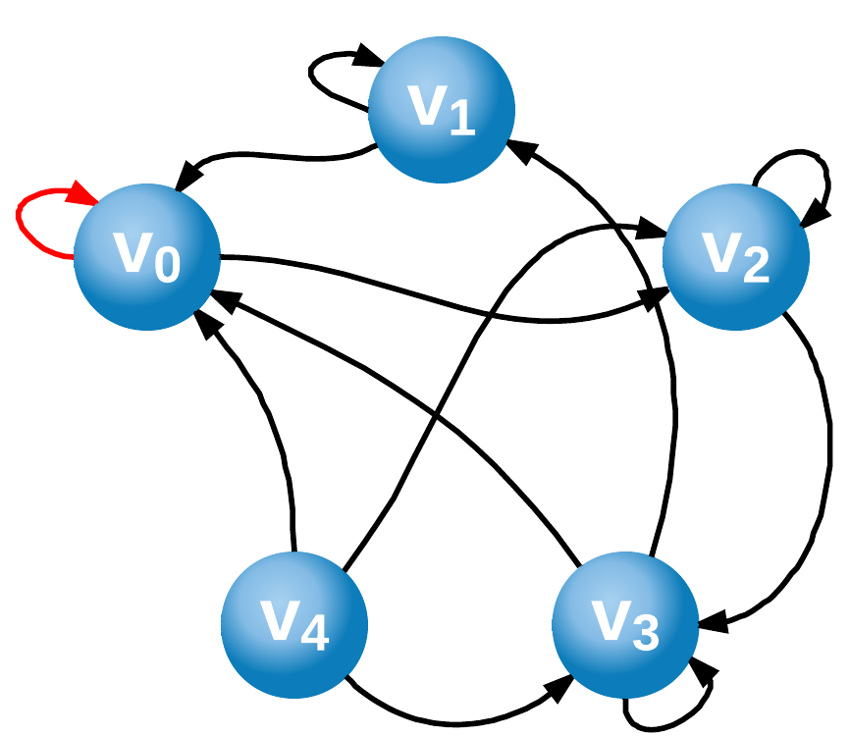

Figure :G3, depicting an edge <v0,v0>

All the edges in Gk are included in G+.

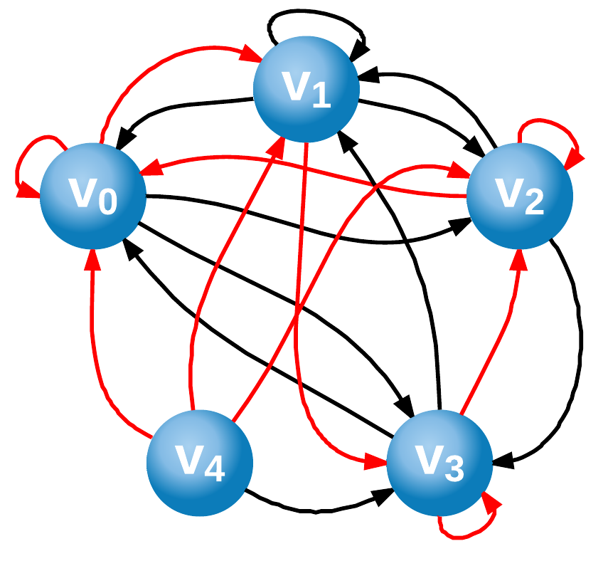

Figure : G+ (Transitive closure of G), with all the edges from G3 highlighted in red

Since v0 = vk, the edge is a self-loop, implying that G+ cannot be anti-reflexive. Therefore G+ is not a strict order.

*Definition of Strict Order:*

*The relation is transitive and anti-reflexive.*

G+ is by definition transitive, so in order for it not to be a strict order, it must not be anti-reflexive which means that it has a self-loop.

Suppose that G+ has a self loop at vertex v.

*See figure 3, vertex v0.*

The edge (v, v) must be in Gk for some k ≥ 1.

*Figure 2 illustrates G3 containing a self-loop at V0.*

The existence of the edge (v, v) in Gk means that there is a path of length k in G that begins and ends at vertex v.

*Figure 1 shows a path of length 3: <v0, v2, v3, v0>*

Thus, there is a cycle of length k in G and G is not acyclic.

**Part 4: Additional Questions**

***The first paragraph is a proof of the statement “If G+ is a strict order, then G has no positive length cycles.” What type of proof structure is used in the first paragraph of the proof?***

The first paragraph of the proof negates the conclusion (*G has no positive length cycles*), and shows that the hypothesis cannot be true as a result. This is a proof by contrapositive.

***What is the value of k in your illustration of the first paragraph?***

The value of *k* in my illustration of the first paragraph is 3.

***Why does a self-loop imply that G+ cannot be anti-reflexive?***

The definition if anti-reflexive is give in Zybook as:

“… for every x ∈ A, it is not true that xRx.” If the graph G of the relation R contains a self-loopat vertex x, then xRx. Therefore the existence of self-loops dictates that the relation R cannot be anti-reflexive.

***What justifies the author’s statement that “Therefore G+is not a strict order”?***

A strict order is transitive and anti-reflexive. The author has shown that the transitive closure under discussion is not anti-reflexive, therefore it cannot be a strict order.